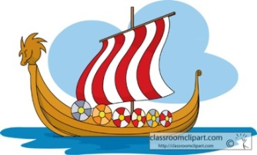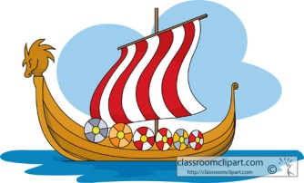

We will be looking in detail at story openings and characterisation in narrative texts using Charles Dickens as our focus author. We will explore stories with different structures and will focus on stories with flashbacks. Our ‘Author of the Half-Term’ is Babette Cole and our work will be linked to her texts, where possible. Poetry will also be a focal point and the children will be creating poems with strong visual imagery. We will also perform poetry.

Key skills include: Revising sentence structure and the use of simple, compound and complex sentences; the use of coordinating and subordinating conjunctions; appropriate word choices and linking paragraphs. We will also explore the use of dialogue in narrative and the different forms this can take.

**Home Learning!**

Maths and English/Topic will be set weekly. Spellings, reading and times tables should be done on a daily basis.

**English**

**Maths**

In Maths we will be learning to recognise and use place value including rounding numbers to the nearest 1, 10, 100 and 1000. We will be identifying and continuing sequences and we will continue to learn times tables up to 12 x 12.

We will also be learning to add and subtract numbers with more than 4 digits using written methods , estimate and use inverse operations to check answers to a calculation, solve problems involving measure, multiply and divide and to identify multiples and factors.

We will extend our knowledge of 3D shapes and angles.

There will also be a focus on reasoning and explaining mathematical concepts.

Our topic is Crime and Punishment and we will be studying crime and punishment through the ages beginning with the Romans, then the Anglo-Saxons and Medieval Age: comparing and contrasting the different eras. We will look at how societies have changed law and order.

In Science we will study Carl Linnaeus and Classification Keys. We will discover how animals and plants are classified based on their similarities and differences. We will create and test classification keys for flaws. We will study micro-organisms and decide whether they are harmful or helpful. Can we find the optimum growing conditions for mould?

In Computing we will be developing an interactive game and creating an e-safety website.

In R.E. we will be learning about Islam.

In Art we will research how artists have represented ‘The HIGHWAY MAN’. We will revise what perspective is and use this to good effect in our own creations. Can we use shading to create contouring as an effect? Can we use watercolours effectively?

Autumn One

**Year 5 Curriculum News**

**Topic**