**Topic**

**Maths**

We will be learning how to:

*recognise the place value of each digit in a three /four digit number (thousands, hundreds, tens, and ones)

*order numbers up to and beyond 1000

*read and write numbers up to 1000 and beyond in numerals and words,

*solve number problems in a variety of contexts

*add and subtract numbers (up to four digits)

*add and subtract numbers with up to 4 digits

*estimate the answer to a calculation and use the inverse operation to check answers

*solve missing number problems, using number facts, place value and more complex addition and subtraction.

*tell the time to the nearest five minutes/ minute using analogue and digital clocks.

*investigate fractions, ratios and proportions of shapes and numbers.

[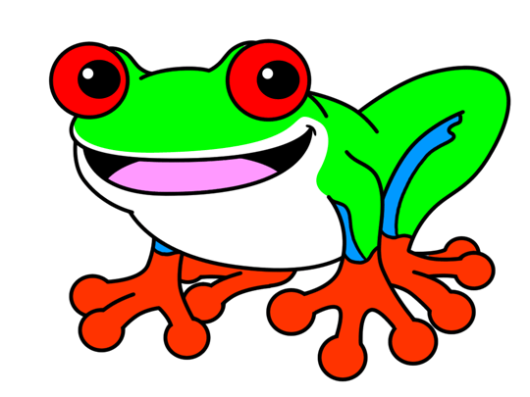](http://www.google.co.uk/url?sa=i&rct=j&q=&esrc=s&source=images&cd=&cad=rja&uact=8&ved=0ahUKEwinwqT0hpPWAhXE7xQKHWoOBsoQjRwIBw&url=http://www.how-to-draw-cartoons-online.com/how-to-draw-a-frog.html&psig=AFQjCNFIbj6BYcv2uRD5QI8VzCYuirjMdg&ust=1504872992890059)

Our topic is ’Rumble in the Jungle’ and we will be learning about rainforests around the world, identifying where they are found using maps, globes and atlases.

As scientists, we will be learning about the four layers of the rainforest. This will include the study of plants and in particular, the function of flowering plants.We will be considering the requirements that plants need for life and growth. This will include investigating how water is transported. We will be exploring the habitats of the rainforest and the living creatures to be found there.

In History we will be learning about the ancestry of rainforest tribes and compare their lives’ to ours.

A stimulus for our art lessons will be the works of Henri Rousseau. We will be creating our own art based on his style using a variety of mediums.

During RE lessons, we will be considering whether taking communion makes someone a Christian and whether ‘light’ is a good symbol for celebration.

In computing we will be focusing on E-safety and consider whether websites are appropriate. We will also be programming animations and creating an interactive toy.



We will:

*read a range of texts as a stimulus for our learning, (fiction and non- fiction). *identify the features of a non-fiction text and apply this knowledge when creating our own information booklet. *write in a range of genres such as fantasy stories, poetry, persuasive and letter writing. *use different key skills. These will include: teaching the difference between compound and complex sentences; exploring how to include powerful adjectives, verbs and adverbs in our writing: express time, place and cause using conjunctions and knowing when to make a new paragraph.

**Home Learning**[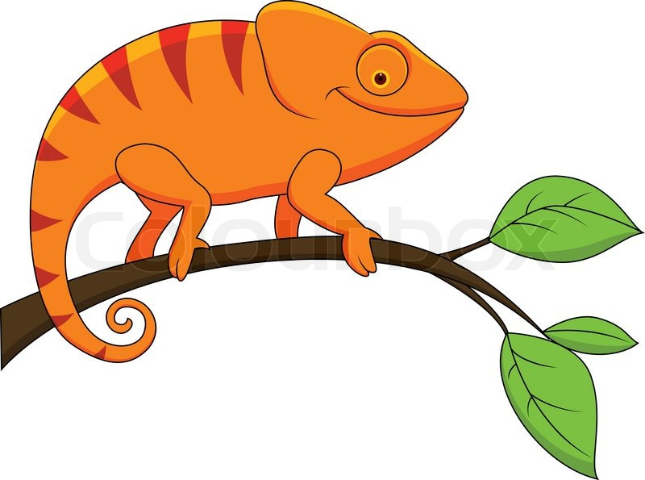](https://www.google.co.uk/url?sa=i&rct=j&q=&esrc=s&source=images&cd=&cad=rja&uact=8&ved=0ahUKEwityNjahpPWAhWGPxQKHUmxAXQQjRwIBw&url=https://www.pinterest.com/pin/443604632029651982/&psig=AFQjCNFVUGcOADvq8x9jfkCyKlet6juLeg&ust=1504872940786590)

Homework will be set weekly. Spellings, reading and times tables should be done on a daily basis.

**Due 2ost October 2017 -** Choose a rainforest animal and create a fact sheet about it.

**Due 15th December 2017-** Design a ‘rainforest’ island. Prepare a speech about why it is a good place to visit.

**Autumn 2017**

**Year 3/4 Curriculum News**

**Rumble in the Jungle**