**Home Learning** [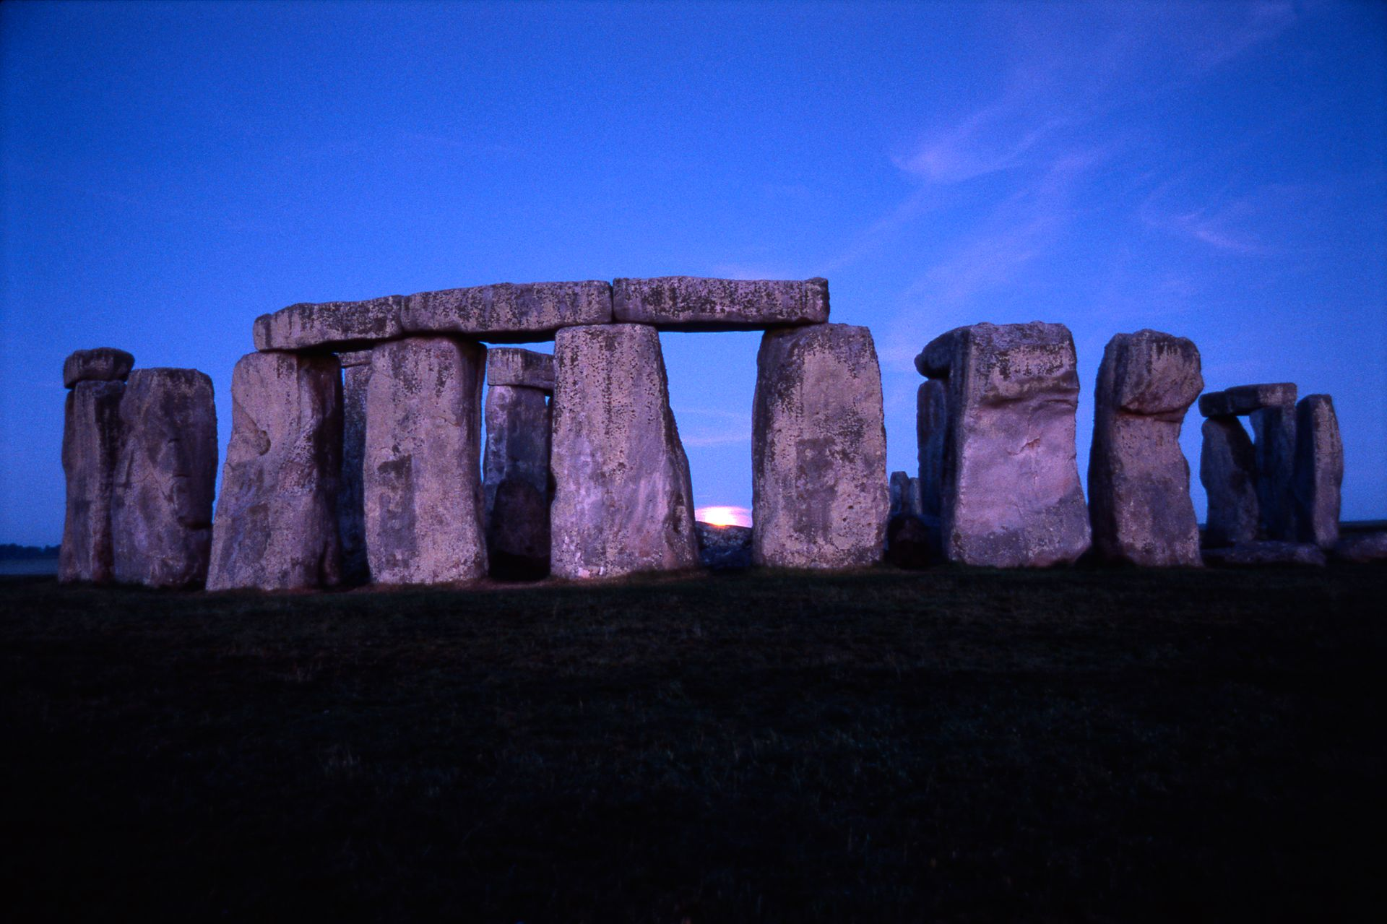](https://www.google.co.uk/url?sa=i&rct=j&q=&esrc=s&source=images&cd=&ved=2ahUKEwifubXpsqjkAhURT8AKHcyUBLMQjRx6BAgBEAQ&url=https://www.dkfindout.com/uk/history/stone-age/stone-age-beliefs/&psig=AOvVaw2uDOOVyW2GBFQVkOF6qc8-&ust=1567178986453853)

Homework will be set weekly. Spellings, reading and times tables should be practised on a daily basis.



We shall :

*read a range of texts as a stimulus for our learning (both fiction and non- fiction). Focus texts include: ‘Stone Age Boy’- Satoshi Kitamura and ‘Stig of the Dump’- Clive King

*use story mapping techniques to help rewrite stories and plan/write our own

*identify the features of a non-fiction text and apply this knowledge *use different key spelling, punctuation and grammar skills. These will include identifying *and using: nouns, adjectives, verbs, adverbs adverbial phrases, past tense, present tense future tense, use of effective word choices, rich varied vocabulary, paragraphs and conjunctions*

*We will also look at the work of the Author Helen Ward.

We shall be learning how to:

*recognise the place value of each digit in a three /four digit number (thousands, hundreds, tens, ones)

*order numbers up to and beyond 1000

*read and write numbers up to 1000 and beyond in numerals and words,

*solve number problems in a variety of contexts

*add and subtract numbers with up to 4 digits

*estimate the answer to a calculation and use the inverse operation to check answers

*solve missing number problems, using number facts, place value and more complex addition and subtraction.

**We shall be focussing on maths ‘mastery’ concepts and ensuring that the children are thinking conceptually and recognising numbers presented in a variety of ways, as well as explaining their answers using reasoning.**

**Topic**

[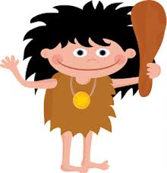](https://www.google.co.uk/url?sa=i&rct=j&q=&esrc=s&source=images&cd=&ved=2ahUKEwi-x5O6sqjkAhUGfMAKHYRTAtwQjRx6BAgBEAQ&url=https://www.whyplay.co/stone-age&psig=AOvVaw0Na8FOoNKif_zuYA6H5RLc&ust=1567178869680210)

Our topic for this half term is ‘The Stone Age.’ To begin our learning we shall be using historical evidence to find out about where prehistoric people settled and how they came to be in Europe. We shall be finding out about how Stone Age people lived and consider what artefacts tell us about beliefs and survival at that time. During our studies we shall be discussing similarities and differences between people and artefacts, such as the difference between the early and later Stone Age. We shall be investigating the era further by identifying key geographical areas using maps, globes and atlases. In Art and Design Technology we shall be using a variety of techniques and mediums, for example when recreating cave art. As scientists, we shall be learning about rocks; comparing and grouping them on the basis of their appearance and simple physical properties. We shall explore how fossils are formed and consider how soils are made from rocks and organic matter. During RE lessons, we shall be looking at the key practices of the Christian faith and some of the differences between denominations or sects. In our PSHE sessions we shall be focussing on celebrating difference by considering identity, society and equality. Focus in computing shall be E-safety and the importance of appropriate use of the internet. As musicians we shall listen to and discuss a range of high-quality live and recorded music. We shall compose and appraise a range of pieces using the interrelated dimensions of music.

**Please see the school website for further information about curriculum skills covered throughout the academic year.**

**Maths**

**Autumn 2019**

**Year 3/4 Curriculum News**

**Year 3/4 The Stone Age**