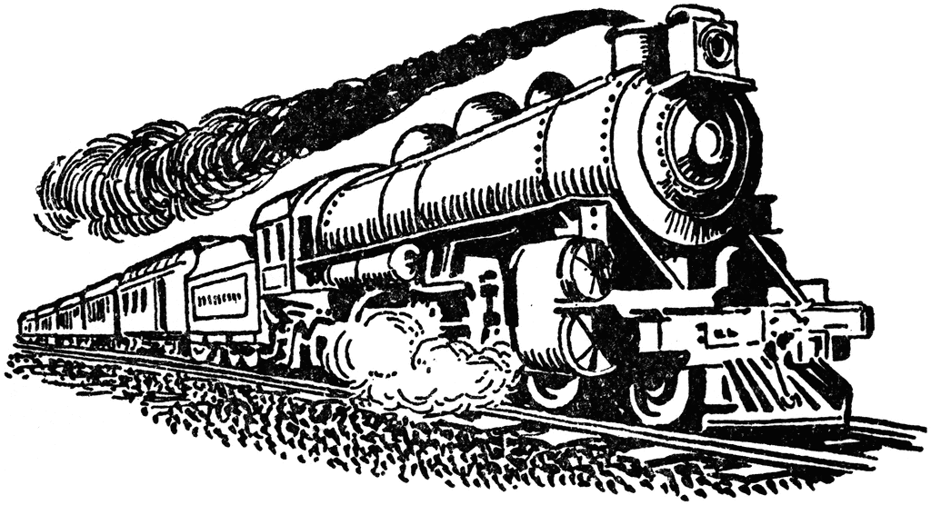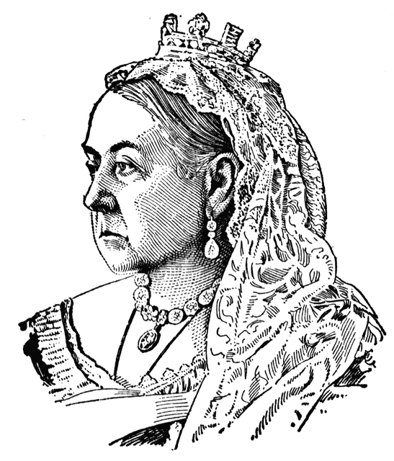

**Maths**

**Year 6 Curriculum News**

**Autumn**

* The children will be using the text ‘Cogheart’ as a stimulus for learning the key skills of writing such as sentence structure and higher level punctuation, for example the colon and semi-colon.
* Children will be using the text as a basis for their work which will include figurative language, speech and argument texts.
* They will also be writing diaries and non-chronological texts based on the ‘The Great British Empire’.
* They will also be drafting, editing and writing pieces of work.

**Home Learning!**

Spellings, reading and times tables should be practised on a daily basis.

English and Maths will be set on a weekly basis.

Children are to take the theme of ‘’The Great British Empire’ and choose a country that once belonged to the Empire. They should then choose to create a piece of work based on that country – art, food, advert, story, model etc. Due in Monday 3rd November.

In Maths we shall be reading, writing and ordering numbers up to 10,000,000. We shall be revising how to round any whole number to the nearest 10, 100 and 1000. We shall be problem solving using negative numbers in context, in addition to solving addition and subtraction problems mentally. We shall be revising written methods for addition and subtraction and multiplication and division and exploring the link between these operations. Comparing fractions, decimals and percentages will also be a key topic for this term. The children will continue to learn times tables and related division facts up to 12 x 12. There will also be a focus on using and applying and explaining mathematical concepts.

**The Great British Empire**

Our topic this term is ‘The Great British Empire’. We are first looking generally at how it grew and how trade started. We shall then focus in on the Victorian industrial period and how the development of lots of areas, such as trains and the sewerage system, affected the country. The children will also study the life of Queen Victoria and Prince Albert and see how they influenced the industry.

A lot of the subjects this term will be connected with our main topic of the ‘The Great British Empire’. In Art, we shall be exploring the art of the Pre-Raphaelites. Children will then create art influenced by this style. In music, children will discover music from around the world and see what the differences are. They will then create pieces of music which have a style taken from a specific country.

In Science this term, we are learning about inventions from the Victorian period. Children will focus on electricity and find out answers to questions such as: How was the use of electricity developed in the home? How are circuits created? What impact does electric light have? What disasters occurred before the safe introduction of electricity?

This term the children will also be having weekly PSHE and RE lessons which will focus on leaders, respect and belonging.

**English**