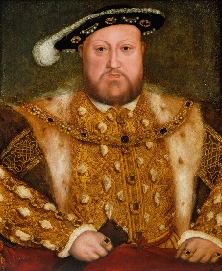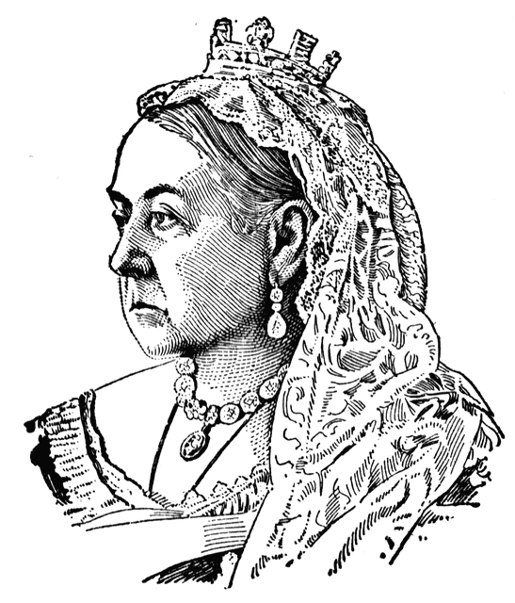

In maths we will be reading, writing and ordering numbers up to 10,000,000. We will be revising how to round any whole number to the nearest 10, 100 and 1000. We will be problem solving using negative numbers in context, in addition to solving addition and subtraction problems mentally. We will be revising written methods for addition and subtraction and multiplication and division and exploring the link between these operations. Comparing fractions, decimals and percentages will also be a key topic for this term. The children will continue to learn times tables and related division facts up to 12 x 12. There will also be a focus on using and applying and explaining mathematical concepts.

**English**

* The children will be using the text ‘The executioner’s daughter’ as a stimulus for learning the key skills of writing such as sentence structure and higher level punctuation, such as colon and semi-colon.
* Children will be using the text as a basis for their work with figurative language, speech and argument texts.
* They will also be writing diaries and non-chronological texts based on the Tower of London, religion, and life of the rich and poor in Tudor Times.
* They will also be drafting, editing and writing pieces of work as well as becoming more familiar with year 6 end of year writing criteria.

**Year 6 Curriculum News**

**Autumn One**

**Who was the most memorable monarch?**

Our topic this term is based on the question ‘Who was the most memorable monarch?’. We will be focusing on a range of skills in different subjects, some of which will be addressed in lessons separate to our topic.

History- to describe and give reasons for the main changes in a period of history, to name the date of any significant date that I have studied and place it on a time line, to use the words era, decade, century, BC, AD to describe the passing of time, to choose, interrogate and evaluate reliable sources of evidence to describe the houses, settlements, leisure and culture activities, clothes, way of life and actions of people, buildings and their uses by people. Describe attitudes and religion of the past, describe what was important to the people from the past and to contrast the lives of the rich and poor.

Geography- to read six figure grid references, symbols and a key on a map.

D+T- to use a range of cooking techniques to prepare and cook food to describe the journey of individual foods and to ensure food is well presented and packaged using other DT skills.

Art- to evaluate my sketch book and explain my ideas, to criticise other people’s work and ideas, to select from a range of materials for the type of artwork I want to produce, to give detailed evaluation of my own and others artwork using technical vocabulary and to adapt my work after criticism.

Music- to know and use standard musical notation to perform and record my music, to use my musical vocabulary to help me understand how best to combine musical elements and to quickly read notes and know how many beats they represent.

R.E- show how inspiration might play a part in how believers interpret texts.

Science- to describe changes as humans develop to old age.

**Maths**

**Home Learning!**

Spellings, reading and times tables should be practised on a daily basis.

English and maths will be set on a weekly basis.

Children are to take the theme of ‘’The Tower of London’ and create a piece of work to show what they have learnt. This could be a poster, story, model etc. The more original the better.

Due in Monday??????