**In Year 3 we shall be learning how to:**

*recall multiplication and division facts for x2/x5/x10/x3/x4/x8 tables-- write and calculate mathematical statements for multiplication and division using the multiplication tables; including for two-digit numbers times one-digit numbers, using mental methods and progressing to formal written methods.

*solve problems, including missing number problems, involving multiplication and division, including positive integer scaling problems and correspondence problems in which n objects are connected to m objects. * add and subtract amounts of money to give change, using both £ and p in practical contexts **In Year 4 we shall be learning how to:** *recall and use the multiplication and division facts up to 12 x 12, multiply and divide mentally. *develop methods to multiply and divide larger numbers using an efficient written method. *find area of rectilinear shapes by counting squares. *recognise and use equivalent fractions **We shall be focussing on maths ‘mastery’ concepts and ensuring that the children are thinking conceptually and recognising numbers presented in a variety of ways, as well as explaining their answers using reasoning.**



This term we shall:

*read a range of texts as a stimulus for our learning (both fiction and non- fiction). Focus texts include: ‘Charlotte’s Web’ by E.B White (author study), ‘Avoid being a Mayan Soothsayer!’ by Rupert Matthews, ‘Chocolate Fever’ by Robert Kimmel Smith and ‘Rain Player’ by David Wisniewski. *write a myth based on traditional Mayan tales using key writing skills *plan and write a newspaper report and a tourist information leaflet using the appropriate style of language *use different key spelling, punctuation and grammar skills. These will include identifying and using: nouns, adjectives, verbs, adverbs adverbial phrases, past tense, present tense future tense, use of effective word choices, rich varied vocabulary, paragraphs and conjunctions

*We will also look at the work of the Author Helen Ward.

**Home Learning** 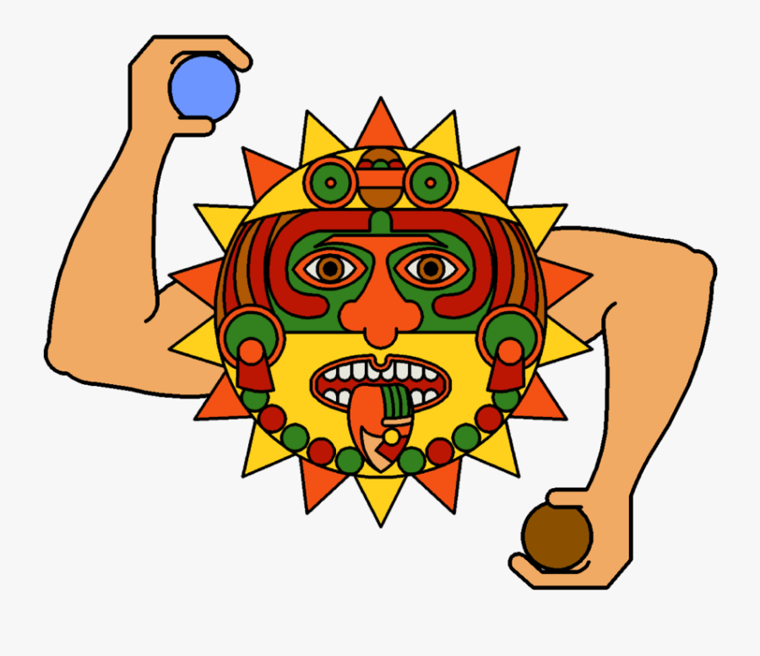

Homework will be set weekly. Spellings, reading and times tables should be practised on a daily basis.

**Maths**

**Topic**

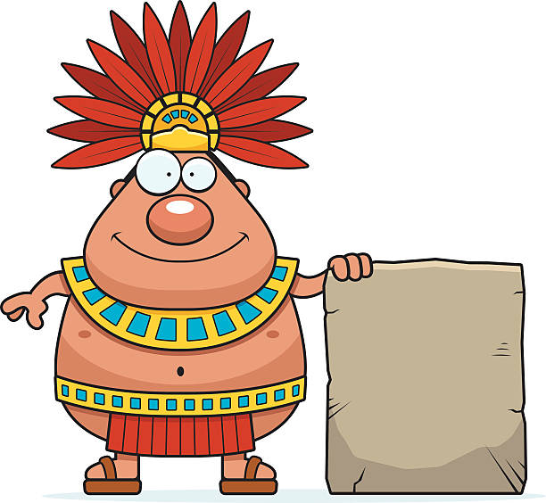Our topic for this half term is ‘The Ancient Maya.’ We shall be using various texts as a stimulus for our work. To begin our learning, we shall be using our research skills to find out about their history. We shall consider such questions as ‘Who were the Maya civilisation?’ and ‘How did they live?’ We shall use our learning to create narratives and information texts for an intended audience. We shall be using our Geography skills to find where they originated from by looking at and comparing maps. As scientists, we shall plan and carry out investigations to look further at changes in state considering whether reactions are reversible or irreversible. Our science lessons will also involve making careful predictions and conclusions as well as collecting and analysing data

During RE lessons, we shall be considering whether people with faith can make choices. In French lessons we shall continue to learn and revise new vocabulary and extend our knowledge a little about Paris and its landmarks. In our PSHE sessions, we shall be focussing on looking at how to deal with uncomfortable social situations and how to deal with cyberbullying. In Computing we shall be using Scratch to build skills with Algorithms. In Art and Design Technology we shall be using a variety of techniques and mediums, for example Papier Maché . We shall evaluate our final results alongside our initial designs.

**Please see the school website for further information about curriculum skills covered throughout the academic year.**

**Spring One 2020**

**Year 3/4 Curriculum News**

**Year 3/4 The Maya.**