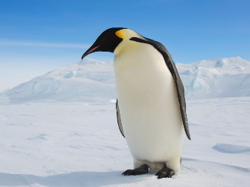

Our topic will be stretched over two half-terms and focussed on ‘The Frozen Planet’. Children will be researching: animals, the impact of climate change and adventurers. They will then use this knowledge to create an eco-fair to end our topic.

A lot of this fascinating, cross-curricular topic will be based on science and geography. For science, we will be researching polar animals and the impact of climate change on them. We will also be conducting icy experiments which will investigate properties of materials. For geography, we will be looking at the environment, as well as investigating data for the weather.

In design and technology, we will be using pieces of plastic (junk modelling) to create structures which represent the frozen planet/plastic pollution/climate change.

We will also be creating David Attenborough style videos in computing to apply the knowledge we have learnt about throughout the term .

More information about the eco-fair will be sent later in the half term.

**Please see the school website for further information about curriculum skills covered throughout the academic year.**

In maths we shall be consolidating our knowledge and application of the formal methods with the four operations – addition, subtraction, multiplication and division.

We will also start looking at algebra within maths questions. We will look at how ‘letters’ stand for missing quantities.

After this we will be revising previous topics to consolidate pupil’s knowledge as well as applying their understanding and skills from more than one topic to solve two/three step questions.

We shall be focusing on our topic as a stimulus for our writing as well as our class book ‘The boy in the girls’ bathroom’.

We will firstly be looking at letter writing in order to send a letter to Whipsnade Zoo to enquire about our class adopted penguins.

After, we will then be using Shackleton’s journey as a basis for some adventure writing.

Through these writing opportunities children will be applying their grammar skills and sentence level skills.

**Home Learning!**

We are trialling a new style of homework this term. Children will have a grid of homework from which they will choose a certain number of the tasks. These homework tasks will be due in by Monday 10th February.

This is in addition to daily times table and spelling practice.

**English**

**Maths**

**“Frozen Planet”**

Autumn Two

**Year 5 Curriculum News**