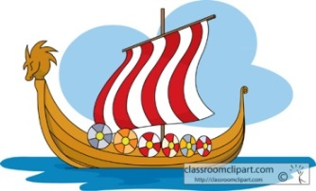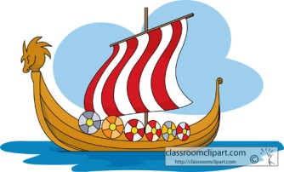

We shall be looking in detail at story openings and characterisation in narrative texts using Sir Arthur Conan Doyle’s ‘The Hound of the Baskervilles’ as our main class text. We shall explore stories with different structures and look at how Sir Arthur Conan Doyle uses strong and powerful imagery to describe his characters and settings. Our ‘Author of the Half-Term’ is Babette Cole and our work will be linked to one of her main texts: Prince Cinders. Key skills include: revising sentence structure and the use of simple, compound and complex sentences; the use of coordinating and subordinating conjunctions; appropriate word choices and linking paragraphs. We shall also explore the use of dialogue in narrative and the different forms this can take.

**Home Learning!**

Maths and English/Topic will be set weekly. Spellings, reading and times tables should be practised on a daily basis.

**English**

**Maths**

In Maths we shall be learning to recognise and use place value including rounding numbers to the nearest 1, 10, 100 and 1000. We shall be identifying and continuing sequences and we will continue to learn times tables up to 12 x 12.

We shall also be learning to add and subtract numbers with more than 4 digits using written methods , estimate and use inverse operations to check answers to a calculation, solve problems involving measure, multiply and divide using efficient methods and identify multiples and factors.

We shall extend our knowledge of 3D shapes and angles.

There will be a focus on reasoning and explaining mathematical concepts.

Our topic is Crime and Punishment and we shall be studying crime and punishment through the ages beginning with the Romans, then the Anglo-Saxons, Medieval age, Tudors and Victorians: comparing the different eras. We shall look at how societies have changed law and order. When studying the famous Alfred Noyes poem: The Highwayman, we shall explore how transport has changed over time and how the physical features of an area has been changed through this development.

In science we shall study Carl Linnaeus and Classification Keys. We shall discover how animals and plants are classified based on their similarities and differences. We shall create and test classification keys for flaws. We shall study micro-organisms and decide whether they are harmful or helpful. Can we find the optimum growing conditions for mould?

In computing we shall be developing an interactive game and creating an e-safety website. In R.E. we shall be learning about Islam.

In art we shall research how artists have represented ‘The HIGHWAY MAN’. We shall revise what perspective is and use this to good effect in our own watercolour creations with contouring and shading.

Autumn One

**Year 5 Curriculum News**

**Topic**