

**English**

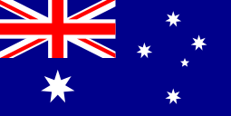

Our topic is ‘Australia’ and we will be looking where it is in the world and where it is in relation to other countries. We will consider how far apart cities are in Australia and how this compares to cities in UK. Do vast differences affect the tourist industry?

We will learn about some of Australia’s main landmarks and use correct geographical language to categorise them. We will research and compose a guide book opening page for a state in Australia.

We will investigate some of the differences between living in the city and the outback in Australia and the effects this has on day-to-day living. We will research the climates in different regions of Australia and compare and contrast them. We will research the effect people have on The Great Barrier Reef.

In Art, we will discover the main symbols and compositions of Aboriginal art and then use this knowledge to effectively use the colours and techniques in our own art work. We will simplify images to use for a cave drawing and use images in the style of Aboriginal cave drawings. We will use dot techniques to paint our own Aboriginal art work. We shall link some of these artistic symbols and notations to some musical compositions.

In Science, we will be continuing to investigate forces. Investigations will include: what is the best and safest material to use for a parachute; and which shape of boat is best to beat the water resistance of a river?

In Computing we will create our own radio podcast, jingle and advertisement using Audacity software.

In R.E. we will be learning about people who inspire us and how they affect our lives, followed by how the disciples were inspired and which famous people have been inspired by the Holy Spirit.

**Home Learning!**

Maths and English/Topic will be set weekly. Spellings, reading and times tables should be practised on a daily basis.

In Maths we will be recapping and consolidating the rules for the four operations (addition, subtraction, multiplication and short division) and using them to solve problems involving measure. These will involve knowing and applying the rules of unit conversion.

Our next topic will be about angles. We will compare acute, obtuse and reflex angles and learn how to draw given angles and measure them in degrees. Then 3D shapes will be studied including cubes and other cuboids. Looking closely at rectangles, we will learn to deduce related facts and find missing lengths and angles.

distinguish between irregular and regular polygons based on reasoning about equal sides and angles

Key skills will include: writing balanced narratives which show cohesion between paragraphs and links between openings and closings; punctuating parenthesis using commas, brackets, colons and dashes and using expanded noun phrases. We will also look at characterisation and effective descriptive techniques.

We will link our writing activities to our main texts: Treasure Island by Robert Louis Stevenson and My Story: Australia.

Performance poetry will be explored based on the work of Michael Rosen and Brian Moses.

**Maths**

**Topic**

**Year 5 Curriculum News**[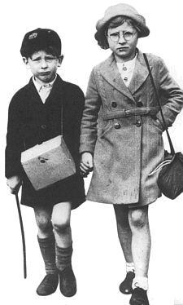](http://www.google.co.uk/url?sa=i&rct=j&q=&esrc=s&source=images&cd=&cad=rja&uact=8&ved=0ahUKEwis_-WFjZDKAhXJVRoKHQXWAMgQjRwIBw&url=http://www.chrisowenonline.co.uk/Children%20of%20the%20blitz%20Home1.htm&psig=AFQjCNHDWI1S2A3pW1PkjImIrXQ4ZpnmJw&ust=1451994987001984)