**Maths**

**Home Learning** 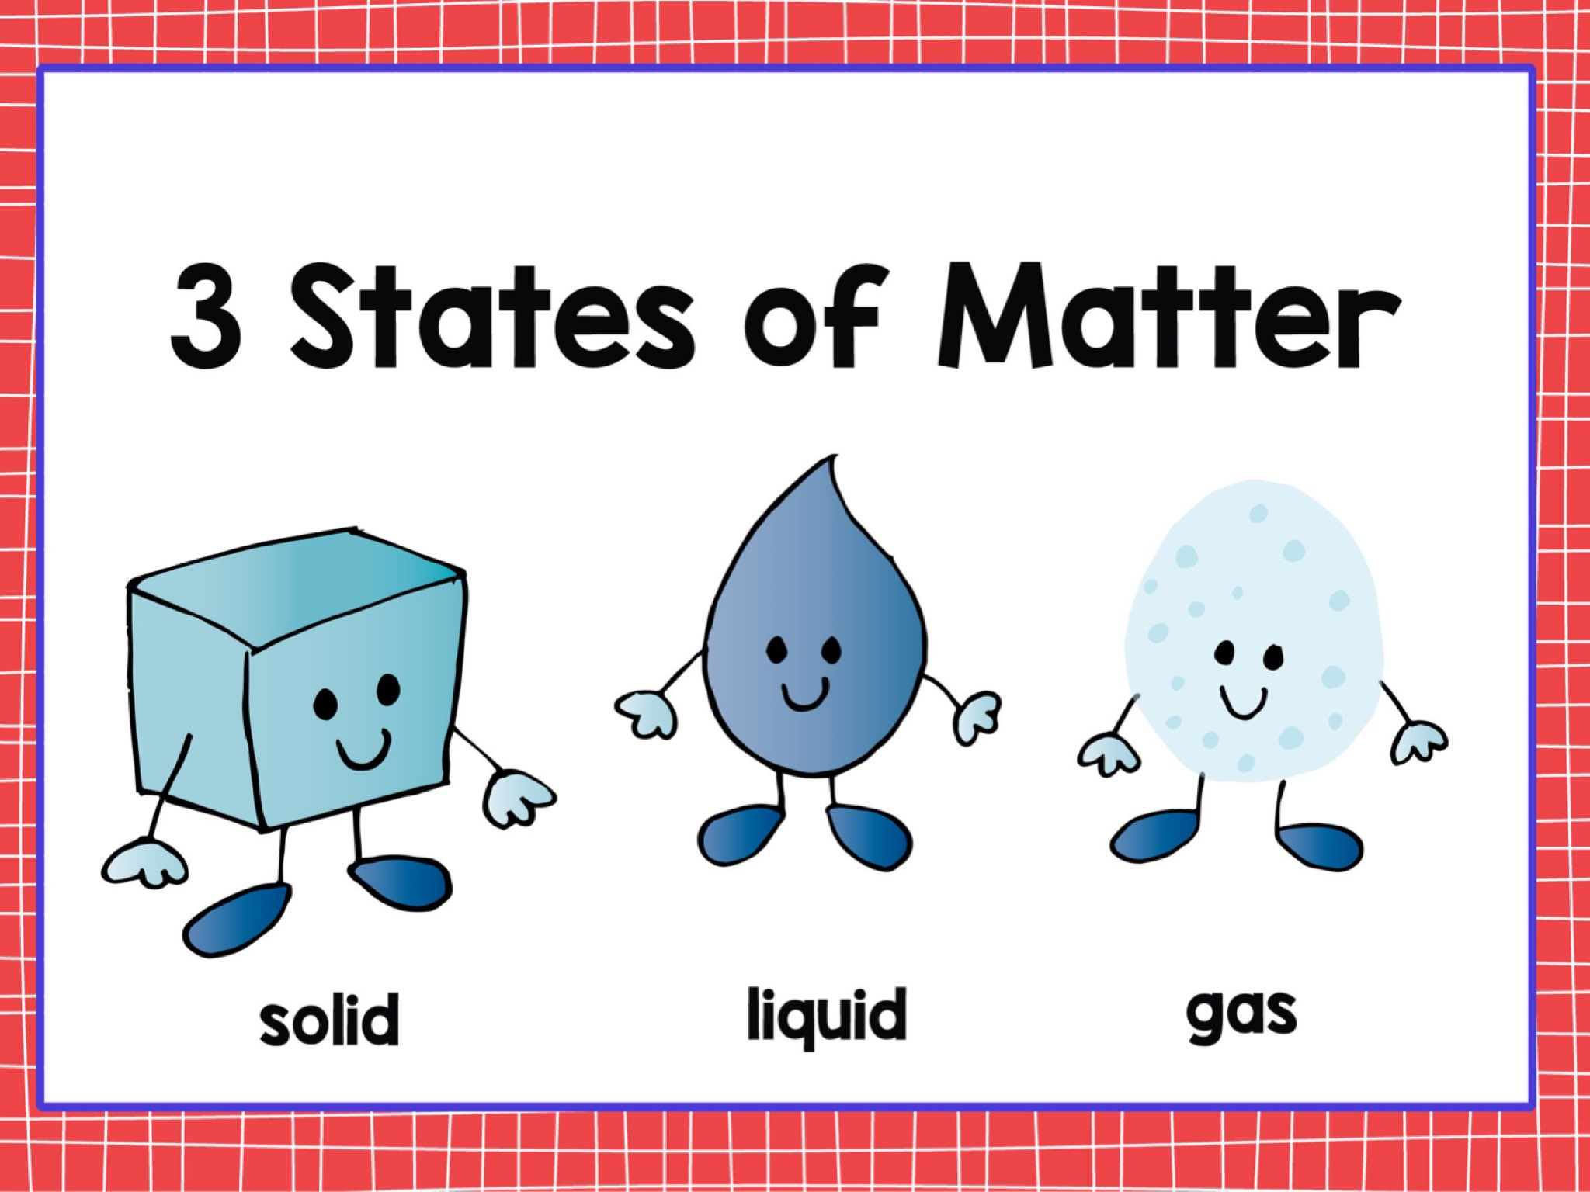

Homework will be set weekly. Spellings, reading and times tables should be practised on a daily basis.



We shall:

*read a range of texts as a stimulus for our learning (both fiction and non- fiction). Focus texts include: ‘’Charlie and the Chocolate Factory’ by Roald Dahl.

*write character descriptions using adjectives, expanded noun phrases and figurative language.

*plan and write a newspaper report, play script, advertisement and letter using the appropriate style of language

*use different key spelling, punctuation and grammar skills. These will include identifying and using: nouns, adjectives, verbs, adverbs adverbial phrases, past tense, present tense future tense, use of effective word choices, rich varied vocabulary, paragraphs and conjunctions.

*We will also look at the work of the Author Helen Ward.

**In Year 3 we shall be learning how to:**

*solve number problems in a variety of contexts

*add and subtract numbers with up to 4 digits

*estimate the answer to a calculation and use the inverse operation to check answers

*solve missing number problems, using number facts, place value and more complex addition and subtraction.

*Recall multiplication and division facts for x2/x5/x10/x3/x4/x8 tables

*use multiplication by repeated addition and scaling. *use division as both sharing and grouping. *use both of the above to derive facts and solve problems. **In Year 4 we shall be learning how to:** *Count backwards through zero to include negative numbers *Measure and calculate the perimeter of rectilinear shapes *Recall and use the multiplication and division facts up to 12 x 12.multiply and divide mentally *Count in multiples of 6, 7, 25 and 100.

**We shall be focussing on maths ‘mastery’ concepts and ensuring that the children are thinking conceptually and recognising numbers presented in a variety of ways, as well as explaining their answers using reasoning.**

**Topic**



Our topic for this half term is ‘States of Matter.’ We shall be using the book ‘Charlie and the Chocolate Factory’ by Roald Dahl as a stimulus. To begin our learning we shall be using our research skills to find out about the history of sweets and create a fact file for an intended audience. During Music sessions, we shall be composing and appraising our own ‘Oompa Loompa’ song in small groups. We shall be using our Geography skills to map the chocolate factory and consider which cities and countries we would distribute the products to. In Art and Design Technology we shall be using a variety of techniques and mediums, for example when designing our own ‘Incredible Gum’ packaging. We shall evaluate our packaging as it is evolving and upon completion. As scientists, we shall be learning about solids, liquids and gases by observing and conducting our own experiments. This will also involve making careful predictions and conclusions.

During RE lessons, we shall be considering whether light is a good symbol for religious celebrations? In French lessons we shall continue to learn and revise new vocabulary. All pupils will construct simple sentences using a writing frame. We will learn about the word order in French when using adjectives through the introduction of the vocabulary associated with colours. In our PSHE sessions, we shall be focussing on alcohol, cigarettes and the law. In computing we shall be creating and manipulating pictures using appropriate programs.

**Please see the school website for further information about curriculum skills covered throughout the academic year.**

**Autumn 2019**

**Year 3/4 Curriculum News**

**Year 3/4 States of Matter**