**Newsletter**

**Spring 1**

**2019**



**Young Voices**

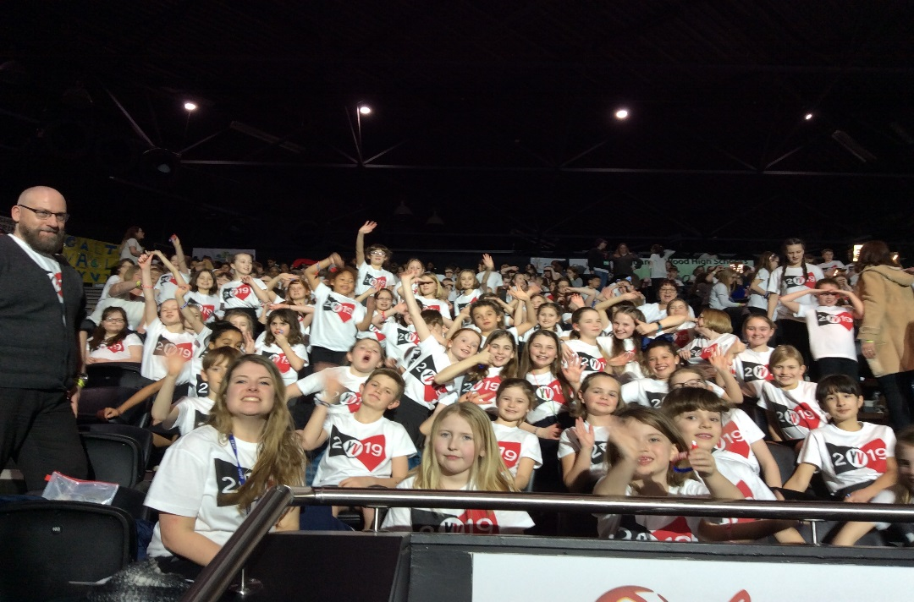

On the 22nd January I had the pleasure of accompanying a group of our KS2 pupils, Mrs Lawrence, Miss Smith and Mrs Fox to a Young Voices performance at the Genting Arena in Birmingham. All of our children were excited but brilliantly behaved throughout the day. We worked hard through the two hour rehearsal to ensure our evening performance to parents would be a success; it certainly was! Many thanks to all of you that came all the way to watch us and for the wonderful comments you fed back to us about the experience.

I wish to say a huge thank you to Mrs Lawrence for arranging the trip and preparing our young vocalists so well.

Below is a picture of the audience and arena lit with small lights; it was very atmospheric.

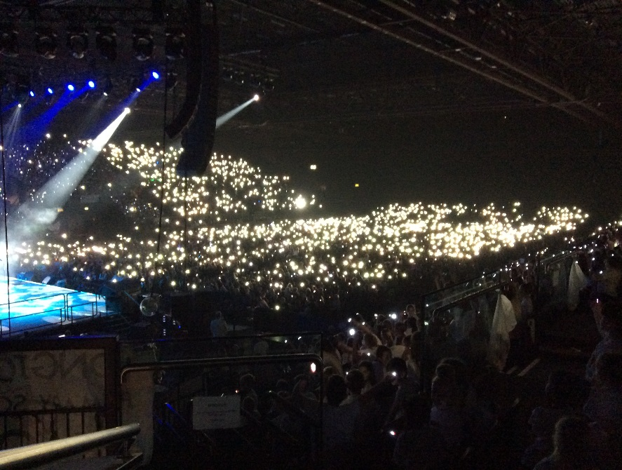

**World Book Day**

We will be celebrating World Book Day on Thursday 7th March. As usual, children will be invited to dress up as a children’s book character (no comic heroes/film only characters or football kits please). The children will need to have a copy of the book in which their character features with them as we will be sharing our books within our classes.

The morning will begin with you all being invited to a “Breakfast with a Book” session. This has proved to be very popular with both pupils and parents in the past. A separate letter will be coming out next week for you to book your places.

Once the school day has started, we will have a catwalk in assembly to display our costumes. A small prize will be awarded to the most original, well executed and imaginative costume (with book) in each class.



**Great British Spring Clean**

We will be taking part in the Great British Spring Clean on 22/03/19. Our children will be encouraged to keep our school site tidy and, weather permitting, we will all do a spot of litter picking around the village.

**Tuck Shop**

I have consulted with our children, spoken with our governing body and received emails regarding the tuck shop that has been provided by our school council. I have decided that the tuck shop will operate on a monthly basis. We all agree the tuck shop teaches our children that having a sweet treat every now and then is a healthy way of maintaining a balanced diet and that it also helps to teach enterprise and money management to those running and operating the shop.

The dates when each tuck shop will operate will be circulated a few days in advance.

Break time snacks on normal days will remain as before, this being fruit and vegetables only.

**Playground Procedures**

I wish to ask for everybody’s cooperation with our procedure on the playground before and after school. A small handful of children are being allowed to bring scooters/bikes onto the playgrounds and use them around other people. Recently this has resulted in an adult being hurt by a child not looking where they were cycling. Obviously I wish to keep everyone safe. I wish to reiterate that scooters and bikes are not to be brought on to the playgrounds at any time.

Similarly, we have a small group of children that play on the playground apparatus after school. Again, this is not safe as there are no school staff outside to supervise how the equipment is being used.

Of course we know that children like to have fun and suggest that at the village playground next to the Pavilion is a more suitable place to play after school with a much greater variety of equipment.

**Outdoor Learning**

As you are aware we are very lucky to have a wonderful woodland area for the children to use to enhance their learning. We have a fire pit which we make very good use of, toasting marshmallows, reading stories and sharing our learning. However, we need your help! We would like to make the fire area a permanent feature and to do this need some tree trunks. They need to be big enough for the children to sit on around the fire. We would need five or six to create the area. Please see the example picture below for an idea of the size we would like. If you can help please contact Miss Hudson (Y5) who is our Outdoor Learning Leader.

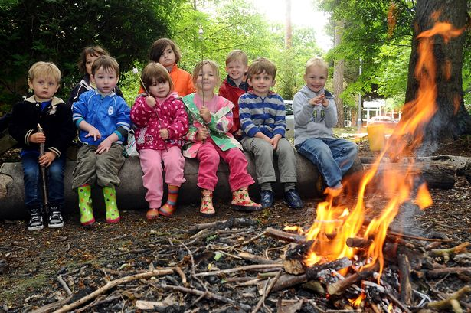

**PE and Outdoor Learning Kits**

Thank you to everybody that ensures their child has full P.E. and outdoor learning kits in school all of the time. Doing so allows us to be flexible with our learning styles and enables us to respond to the children’s needs. When it snowed a few days ago, the vast majority of children had suitable clothing in school to go out and play in; this stopped them getting too wet or cold.

**School Uniform**

Staff have been noticing that there has been an increase in the number of pupils were clothing to school that is not part of our school uniform. Please check your child’s uniform complies with the standard we expect. Uniform details are outlined in your child’s Home/School Book and on our website.

**Spring Fayre**

Our F.O.H.S. have been busy getting ready for this year’s spring fayre. It will be held on Saturday 27th April and will be as exciting and enjoyable as it was last year.

We will be having a non-uniform day on Friday 29th March to collect items for the tombola’s; these being either a donated bottle of your choice or chocolates. Please send your child’s item into school on Friday 29th March.

**Sports Day**

Sports Day will take place on 20/06/19 this year and start at 9:30. The children’s events will be followed by a house fun run (adults included) to raise money for a new purpose built cancer centre at Milton Keynes Hospital.

After this we will hold another family picnic where you are welcome to eat with your child/family and friends on the field.

More details will be in my newsletter in Summer Term 1.

To avoid disappointment if the weather is poor on 20/06/19, I have scheduled two alternative dates. These being firstly on the 27/06/19. Again if this is rained off the second alternative date will be 11/07/19.

**Diary Dates**



***Please note all the dates and times shown here are accurate at the time of the publication of this newsletter. Any unforeseen event may happen that could cause alterations to the information listed below; if this does occur we will endeavour to let you know as quickly as possible.***

14/02/19 Valentine Disco - KS1 4.30- 6.00

KS2 6.30 – 8.00

15/02/19 End of term at 3:15

25/02/19 Inset Day

26/02/19 Spring Term 2 begins for children

26/02/19 Cedar Class Parents Evening 3:30 – 5:30

27/02/19 Cedar Class Parents Evening 3:30 – 5:30

04/03/19 Additional Y6 Parents’ Evening 3:30 -6:00

05/03/19 Parents’ Evening (all classes except Cedar) 5.00- 8.00

06/03/19 Parents’ Evening (all classes except Cedar) 3.30 – 6.00

07/03/19 World Book Day (See attached)

22/03/19 Great British Spring Clean (see above)

03/04/19 Y3/4 Grendon Residential Parents’ Meeting

Select a time 8:30/3:20/5:30

04/04/19 Easter Disco - KS1 – 4.30- 6.00

KS2 6.30 -8.00

05/04/19 End of term at 3:15

23/04/19 Summer Term 1 begins

27/04/29 Spring Fayre

29/04/19 – 01/05/19 Y3/4 Grendon visit

13/05/19 – 17/05/19 End of KS2 SATs

20/05/19 Choir/Music Concert – invitation only 5:00

24/05/19 Summer Term 1 ends at 3:15

03/06/19 Summer Term 2 begins

04/06/19 France Residential Parents’ Meeting

8:30/ 3:20/5:30

05/06/19 Urban Strides workshop – KS2

20/06/19 Sports Day/Fun Run/Family Picnic

(see above:)

03/07/19 KS2 Play 6:30

04/07/19 KS2 Play 6:30

15/06/19 Transition Day

16/07/19 Parents’ Evening – Meet your child’s new teacher

18/07/19 Y6 Leavers’ Assembly 2:30

19/07/19 Summer Term 2 ends at 3:15

03/09/19 and 04/09/19 Inset Days – staff only

04/09/19 Autumn Term 1 begins

I hope that you all have a safe and happy half term.

Ryan Fensham-Brown

[ryan.brown@hanslope.milton-keynes.sch.uk](mailto:ryan.brown@hanslope.milton-keynes.sch.uk)

