**Maths** [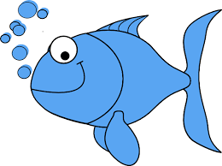](https://www.google.co.uk/url?sa=i&rct=j&q=&esrc=s&source=images&cd=&ved=2ahUKEwjAnNTugc3fAhVG4YUKHWSIBNEQjRx6BAgBEAU&url=https://www.kisspng.com/png-one-fish-two-fish-red-fish-blue-fish-bluefish-clip-567946/preview.html&psig=AOvVaw1iwNHI2FacZG722jXo2tBx&ust=1546446878352145)[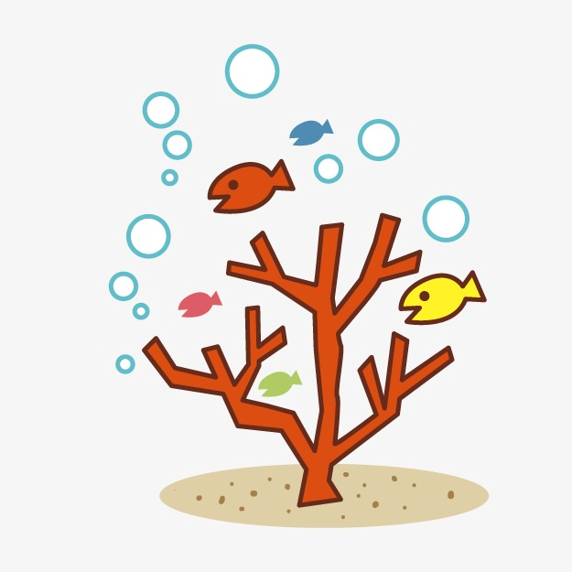](https://www.google.co.uk/url?sa=i&rct=j&q=&esrc=s&source=images&cd=&ved=2ahUKEwiwro2Ggc3fAhUNCxoKHW54AdgQjRx6BAgBEAU&url=https://pngtree.com/freepng/cartoon-coral_1297295.html&psig=AOvVaw3khGrLhQmiVXOrEj_2XAlB&ust=1546446682874168)

**Home Learning**  [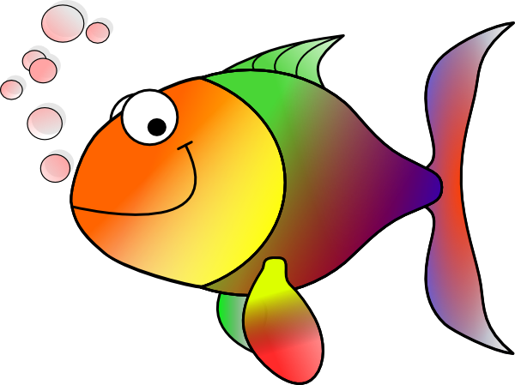](http://www.google.co.uk/url?sa=i&rct=j&q=&esrc=s&source=images&cd=&cad=rja&uact=8&ved=2ahUKEwiH-MennM3fAhWFy4UKHZpgALoQjRx6BAgBEAU&url=http://www.clker.com/clipart-11832.html&psig=AOvVaw1MnI9SHbOSGYLBKJHwjIm7&ust=1546454013945504)

Homework will be set weekly. Spellings, reading and times tables should be practised on a daily basis.

Due Friday 22nd February: Find out about a famous ocean explorer and create a fact file.

Due Friday 5th April: Create your own model of an imaginary sea creature.

[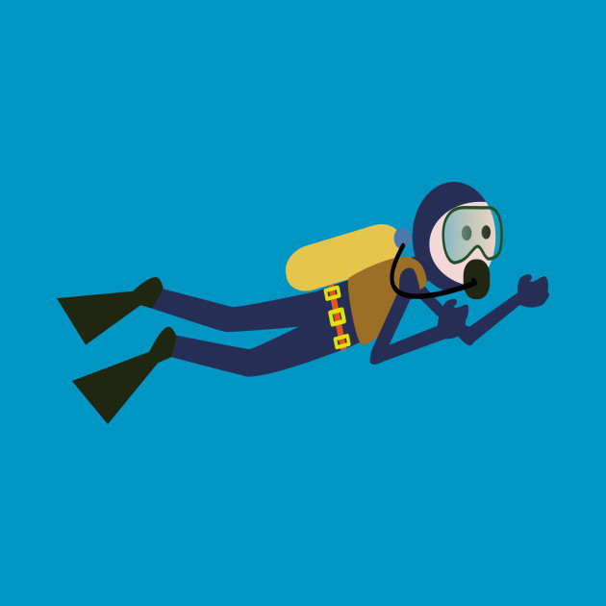](https://www.google.co.uk/url?sa=i&rct=j&q=&esrc=s&source=images&cd=&cad=rja&uact=8&ved=2ahUKEwj72fLegM3fAhUJzhoKHWcYAy4QjRx6BAgBEAU&url=https://www.teepublic.com/kids-hoodie/1576842-limited-edition-exclusive-cartoon-scuba-diver&psig=AOvVaw0-7R1ML3NXCala2NZYKPsb&ust=1546446594745655)

We shall be learning how to:

*read a range of texts as a stimulus for our learning (both fiction and non- fiction).

*use story mapping techniques to help plan creative writing.

*identify, discuss and apply the features of explanation texts, poetry and reports such as newspapers.

*use key spelling, punctuation and grammar skills. These will include: expanded noun phrases, using paragraphs, identifying synonyms and antonyms, using the correct standard verb forms, identifying word families and using conjunctions, verbs and adverbs, prepositions and present-perfect tense in our writing.

*write creatively based on the works of the Author Betty G Birney.

[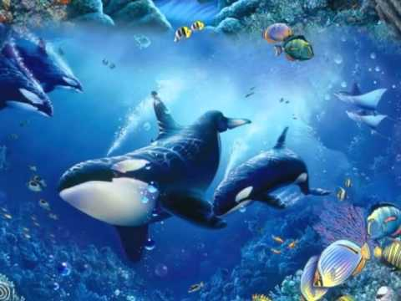](https://www.google.co.uk/url?sa=i&rct=j&q=&esrc=s&source=images&cd=&cad=rja&uact=8&ved=2ahUKEwj7ktSrns3fAhVC1xoKHSu8ChYQjRx6BAgBEAU&url=https://www.youtube.com/watch?v%3DLy4DCjWsI6w&psig=AOvVaw0IS7leNj_soumkqamCK_tb&ust=1546454565277098) We shall be learning how to:

*solve problems involving addition and subtraction using measurement, fractions and counting below zero.

*explain the representation of positive numbers as Roman Numerals.

*solve addition and subtraction problems in different contexts, including data , using number facts, place value, counting, mental and written methods.

*identify that fractions are numbers and learn to understand the meaning of the denominator and numerator.

*explain the relationship between decimals and fractions.

*solve problems involving multiplication and division.

*recognise horizontal, vertical, parallel and perpendicular lines.

*identify acute, obtuse and right angles in 2D shapes.

*explain how we know that an observation is correct and explain methods and solutions.

*derive facts and solve problems.

*locate points on a grid in the first quadrant.

*explain and reason methodologies. [](https://www.google.co.uk/url?sa=i&rct=j&q=&esrc=s&source=images&cd=&ved=2ahUKEwiwro2Ggc3fAhUNCxoKHW54AdgQjRx6BAgBEAU&url=https://pngtree.com/freepng/cartoon-coral_1297295.html&psig=AOvVaw3khGrLhQmiVXOrEj_2XAlB&ust=1546446682874168)

**Topic**

[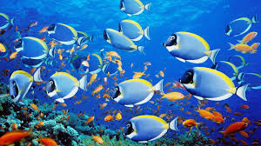](http://www.google.co.uk/url?sa=i&rct=j&q=&esrc=s&source=images&cd=&cad=rja&uact=8&ved=2ahUKEwjZvsLO_8zfAhUMyoUKHbqUB9sQjRx6BAgBEAU&url=http://reasideacademy.co.uk/2018/02/02/the-blue-abyss/&psig=AOvVaw1UZOqI7Zg8DKRYbTUp3mxH&ust=1546446310447008)

Our topic for this term is ‘Blue Abyss.’ We shall be learning about bodies of water, including how seas and oceans are formed. We shall be investigating their geographical features by using maps, globes and atlases. During the term we shall be finding out about life in the depths, including the relationship between predators and prey. We shall also be learning about turtle migration. We shall be exploring some environmental issues that involve the ocean such as plastic pollution and the consequences of global warming. In Art we shall be learning about the works of famous artists and comparing styles. In Design Technology we shall be planning and creating our own dioramas. Upon completion, we shall be evaluating the final product. During RE lessons, we shall be discussing whether a holy journey is necessary for believers and consider whether, with Lent in mind, people should ‘give things up’ for their faith. Our focus in PHSE is exploring the subject of alcohol and the law. In computing we shall be using Scratch Planet PDA and shall continue to learn how to use the internet with safety in mind at all times. We shall also continue to learn the recorder in music lessons, focusing on listening with attention and recalling sounds with increasing aural memory.

As scientists, we shall be finding out about electricity during the first half term. This will include talking about the importance of electrical safety and the making of electrical circuits. During the second half term, we shall be learning about sound. Lessons will be based around exploring how sound travels, pitch, volume and vibrations!

**Spring 2019**

**Year 3/4 Curriculum News**

**Year 3/4 Blue Abyss**