[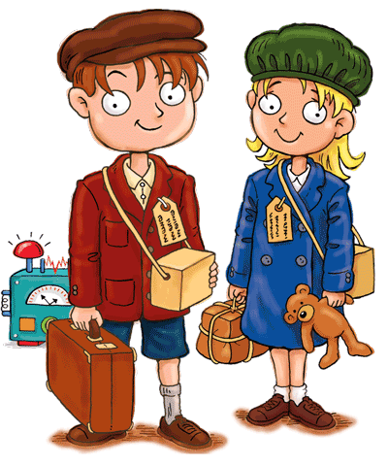](http://www.google.co.uk/url?sa=i&rct=j&q=&esrc=s&source=images&cd=&cad=rja&uact=8&ved=2ahUKEwifsPjxsrTaAhXBRhQKHTxsAHMQjRx6BAgAEAU&url=http://moziru.com/explore/History%20clipart%20wwii/&psig=AOvVaw1Ige31EZhgFtfbvcHXmwR2&ust=1523610818527758)[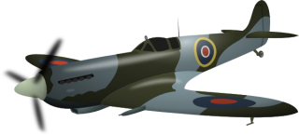](http://www.google.co.uk/url?sa=i&rct=j&q=&esrc=s&source=images&cd=&cad=rja&uact=8&ved=2ahUKEwj2xt2Ds7TaAhUCORQKHXcDBVgQjRx6BAgAEAU&url=http://www.clker.com/clipart-supermarine-spitfire.html&psig=AOvVaw0ukihWBvlHFEYEvtZ7Zc-N&ust=1523610894718784)

**Year 6 Curriculum News**

**Spring 2018**

**Maths**

The core texts for this term will be Goodnight Mr Tom, War Horse, The Diary of Anne Frank and Rose Blanche.

All English lessons will be linked closely to these core texts, we will be focusing particularly on the Year 6 standard criteria and ensuring that children include the criteria in all their writing across a range of genre.

Children will be drafting, editing and redrafting different forms of writing.

**Britain at War**

**Home Learning!**

Spellings, reading and **times tables** should be practised on a daily basis.

Due in the Monday 3rd June – We would like you to create a model of something related to World War One/Two. This could be a tank, Anderson shelter, war horse, plane… anything! The model can also be created out of any material.

In the lead up to SATs, we shall be going through most of the curriculum again – place value, the four operations, fractions, percentages, proportion, ratio and shape problems.

We shall be using our knowledge to answer reasoning questions which sometimes require more than one maths skill.

We shall also be practising being efficient, but careful, when completing mental math questions.

**It is important that children are still practising times tables at home.**

After SATs, we will be researching mathematic ideas such as the Fibonacci sequence.

**English**

Our topic is Britain at War. This term we will be looking at the causes of World War One and how this led onto World War 2. We will also be looking at life both at home (Blitz, Anderson Shelter and evacuees) and away (trenches and battles). We will also take a look at the Holocaust through studying Anne Frank.

In design and technology, we will be creating our own gas mask boxes. We will be learning why people had them and what they were for. We will take our boxes on our trip to Holdenby House. We will also be focusing on nutrition and rationing. As part of this topic, children will learn about the types of foods that were rationed and we will cook some dishes that would have be eaten during War times.

In music, we will be considering the importance of songs to keep up the spirits of soldiers and people at home. Children will learn the words to some 1940’s songs and perform them in groups.

In science, we will be looking at forces and light. We will be creating circuits and fixing circuits in order to create light. We will also be looking at flight and the use of air resistance.