[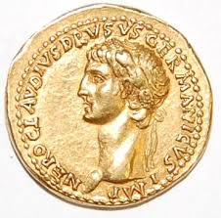](https://www.google.co.uk/url?sa=i&rct=j&q=&esrc=s&source=images&cd=&ved=2ahUKEwiHm_qi0cLhAhWtxoUKHdlTBw8QjRx6BAgBEAU&url=https://www.mylearning.org/stories/the-raging-romans-/435&psig=AOvVaw3klzN99GzJqI_EvE_Jwnd_&ust=1554885962125053)We shall be learning how to:

*derive facts, solve and explain methods and solutions.

*solve addition and subtraction problems in different contexts, including looking at data, using number facts, place value, counting, fractions, mental and written methods.

*explain and show why one fraction is bigger than another

*explain the relationship between decimals and fractions.

*solve problems involving multiplication and division using formal methods.

*explain the representation of positive numbers as Roman Numerals.

*explain and show how to tell the time and use knowledge of different units of time to solve problems.

*identify parallel and perpendicular lines, acute, obtuse and right angles in the context of 2-D shapes. *measure the perimeter and find the area of simple 3-D shapes.

*convert between different units of measures

**Home Learning**  [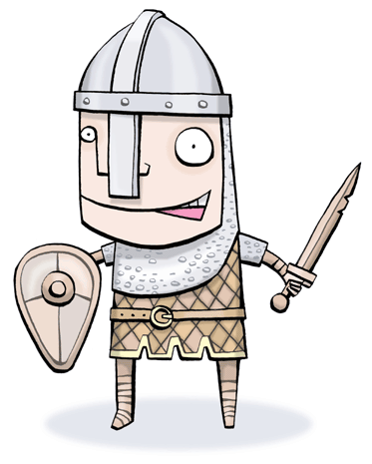](https://www.google.co.uk/url?sa=i&rct=j&q=&esrc=s&source=images&cd=&cad=rja&uact=8&ved=2ahUKEwjEgrOm0sLhAhVQz4UKHQqJCOEQjRx6BAgBEAU&url=https://olympicresearcher.wordpress.com/2013/08/13/whats-your-writing-style-do-you-worship-words-from-anglo-saxon-or-do-you-favor-french-forms-an-interesting-history-and-disection-of-both-styles/&psig=AOvVaw02hd8fdJ6bXtVCkBZY0UNC&ust=1554886628869794)

Homework will be set weekly. Spellings, reading and times tables should be done on a daily basis.

Due Friday 24th May: Create your own maths worksheet for a child using Roman numerals in your calculations.

Due Friday 12th July: Make a 3D model of a Roman Villa.

**Maths** [](https://www.google.co.uk/url?sa=i&rct=j&q=&esrc=s&source=images&cd=&ved=2ahUKEwjAnNTugc3fAhVG4YUKHWSIBNEQjRx6BAgBEAU&url=https://www.kisspng.com/png-one-fish-two-fish-red-fish-blue-fish-bluefish-clip-567946/preview.html&psig=AOvVaw1iwNHI2FacZG722jXo2tBx&ust=1546446878352145)[](https://www.google.co.uk/url?sa=i&rct=j&q=&esrc=s&source=images&cd=&ved=2ahUKEwiwro2Ggc3fAhUNCxoKHW54AdgQjRx6BAgBEAU&url=https://pngtree.com/freepng/cartoon-coral_1297295.html&psig=AOvVaw3khGrLhQmiVXOrEj_2XAlB&ust=1546446682874168)

[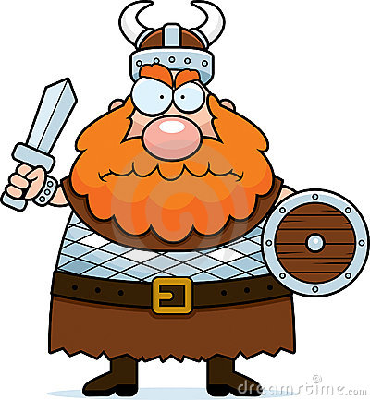](http://www.google.co.uk/url?sa=i&rct=j&q=&esrc=s&source=images&cd=&cad=rja&uact=8&ved=2ahUKEwjElfj70cLhAhVGzBoKHQR-BL8QjRx6BAgBEAU&url=http://www.easyfreeclipart.com/viking-cartoon-vector-clipart.html&psig=AOvVaw1XeKFfRdSBz4M0HovvojiH&ust=1554886465436727)

We shall be learning how to:

*read a range of texts as a stimulus for our learning (both fiction and non- fiction). This will include Shakespeare’s ‘Julius Caesar.’

*use story mapping techniques to help plan creative writing.

*identify, discuss and apply the features of explanation texts, poetry and reports such as newspapers.

*use key spelling, punctuation and grammar skills. These will include: expanded noun phrases, using paragraphs, identifying synonyms and antonyms, using the correct standard verb forms, identifying word families and using conjunctions, verbs and adverbs, prepositions and present-perfect tense in our writing.

*write creatively based on the works of the authors Antony Browne and Jon Scieszka.

**Topic**

[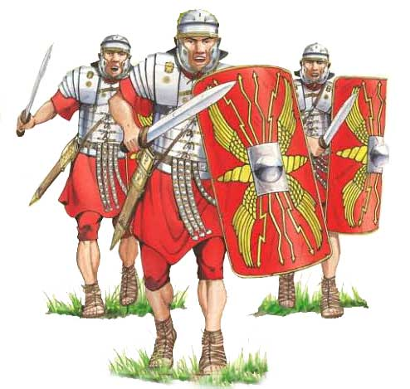](https://www.google.co.uk/url?sa=i&rct=j&q=&esrc=s&source=images&cd=&cad=rja&uact=8&ved=2ahUKEwjLiK7R0MLhAhVSxhoKHcHRCngQjRx6BAgBEAU&url=https://www.romanobritain.org/index.php&psig=AOvVaw3klzN99GzJqI_EvE_Jwnd_&ust=1554885962125053)Our topic for this term is ‘Invaders and Settlers.’ We shall be learning about how the Romans, Saxons and Vikings impacted Britain. We shall be using evidence to find out about their way of life such as housing and settlements, culture and leisure activities. We shall also be learning about the similarities and differences between people in the past, events and objects (artefacts). We shall consider how change occurred during this time period. In Art and Design Technology we shall be planning, making and evaluating a mosaic tile and Roman shield. We shall use a range of tools, materials and equipment.

During RE lessons, we shall be discussing whether Jesus really performed miracles and whether prayer can change things. Our focus in PSHE is exploring Growth Mindset, in particular resilience. In computing we shall be using word processing skills and continue to learn how to use the internet with safety in mind at all times. We shall also continue to learn the recorder in music lessons, focusing on reading musical notation and playing with clarity and control.

As scientists, we shall be finding out about light during the first half term. This will include investigating reflection and shadows. During the second half term, we shall be learning about forces and magnets. Lessons will be based around exploration, such as considering how things move on different surfaces and predicting whether two magnets will attract or repel each other, depending on which poles are facing.

**Summer 2019**

**Year 3/4 Curriculum News**

**Year 3/4 Invaders and Settlers**