**Year 6 Curriculum News**

**Autumn 2017**

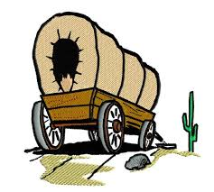

[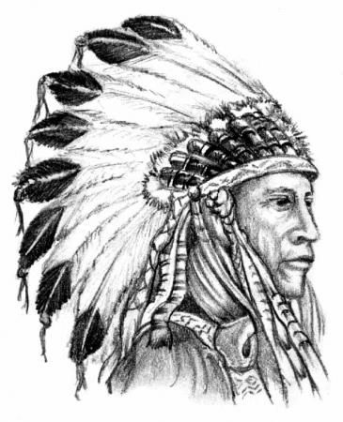](https://www.google.co.uk/url?sa=i&rct=j&q=&esrc=s&source=images&cd=&cad=rja&uact=8&ved=0ahUKEwjf2N7t0o3WAhWJ1hQKHTLiBOUQjRwIBw&url=https://www.pinterest.com/joseeduardoribb/tatuagens/&psig=AFQjCNGI1kmtEDK1l36GmCL4swrQbaQoIg&ust=1504687215607610)

**Home Learning!**

Spellings, reading and times tables should be done on a daily basis.

English and Maths will be set on a weekly basis.

Children are to take the theme of ‘wagons’ and create a piece of their choice. This could be a model, a sketch, a fact sheet or even a story. Due date Tuesday 31st October

**Maths**

In Maths we will be reading, writing and ordering numbers up to 10,000,000. We will be revising how to round any whole number to the nearest 10, 100 and 1000. We will be problem solving using negative numbers in context, in addition to solving addition and subtraction problems mentally. We will be revising written methods for addition and subtraction and multiplication and division and exploring the link between these operations. The children will continue to learn times tables and related division facts up to 12 x 12. We will extend our knowledge of 3D shapes and angles. There will also be a focus on using and applying and explaining mathematical concepts.

**English**

* The children will be exploring the novel ‘Holes’ by Louis Sachar in class.
* Children will be using the text as a basis for their work with figurative language, speech and argument texts.
* They will also be writing diaries and non-chronological texts based on the Wild, Wild West.
* They will also be drafting, editing and writing pieces of work.
* Through these lessons they will also be consolidating their understanding of grammar terms and learning to use a colon and semi-colon.

**Wild Wild West**

Our topic is Wild, Wild West. In this half term we are focusing on different aspects of American culture. We will start of by looking at how the Native Americans used to live and what they used to believe. Children will then learn why people migrated to America and the impact the new settlers had on this new land. They will also consider what life was like for these early settlers.

In the other half term we will also look at modern America and look at influential characters such as Martin Luther King.

A lot of the subjects this term will be connected with our main topic of the Wild, Wild West. In Art, we will be exploring the use of Haida symbols and how we can use these in our own pieces of art. In Design and Technology, we will be crafting traditional woven blankets made originally by Native Americans. The children will also be exploring the culture of the Native Americans and settlers by their music.

In Science this term, we are learning about inheritance and adaptation and linking this with our topic. Children will learn about the animals and plants of America, how they have evolved and adapted to the impact of the changing country.

This term, Year six will be learning German, which will be taught by Mrs Czornyj.