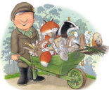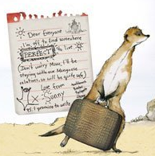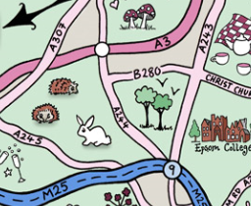

**Our Author Studies this term are:**

Emily Gravett

Nick Butterworth

**Home Study!**

Find out about what life was like for your parents/ grandparents at school.

If possible, read any letters that come in the post (check with the person they are addressed to first) and see what they have in common or how they are different. You can bring examples to share if you like.

Where possible English lessons will be taught through topic. Our topic this term is ‘**Hanslope Detectives**’ We will be exploring, reading and writing recounts based on the book ‘Henry’s Map’ and journeys around the village, where we will use our Geographical skills to find out about the local area and draw maps. We will look at the history of schools in the villages, especially boarding schools and read and write letters. We will explore the impact of WW2 on Hanslope and create army trucks. We will learn about Castlethorpe Castle and explore a range of narrative’s set in castles then create our own. We will design historical items; compare and choose appropriate materials and write instructions for our designs. We will also learn about the patron saints and their corresponding countries.

We will cover a variety of English skills through these topics, including: Using punctuation correctly, including capital letters, full stops, exclamation marks, question marks, commas and apostrophes; spelling more accurately; beginning to join our handwriting and planning and editing our writing. We will also use a wider range of vocabulary in our writing including noun phrases and suffixes, explore and write different sentence types and use conjunctions to extend our sentences.

This term Maths is focussed on our knowledge and understanding of number. We are counting, adding and subtracting both using written methods and in our heads, using our knowledge of place value and number facts such as number bonds.

We will be applying this knowledge of number to measure; ordering, representing and estimating.

We will identify shapes, compare their properties and begin to read and record data.

We will revisit multiplication and division and begin to explore written methods for these.

**Maths**

**English/Topic**

**Year 2 Curriculum News**