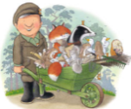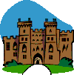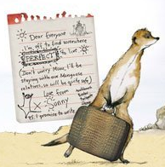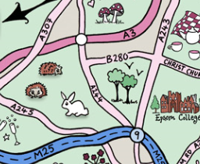

Where possible English lessons will be taught through topic. Our topic this term is ‘**Hanslope Detectives**’ We shall be exploring, reading and writing recounts based on the book ‘Henry’s Map’ and journeys around the village, where we shall use our Geographical skills to find out about the local area and draw maps. We shall look at the history of schools in the village, especially boarding schools and read and write letters. We shall find out about the history of transport and design and build our own trucks. We shall learn about Hanslope Castle and explore a range of narratives set in castles then create our own. We shall design historical items; compare and choose appropriate materials and write instructions for our designs. We shall learn about the patron saints and their corresponding countries. We shall also find out about dinosaurs and where they were found in the UK.

We shall cover a variety of English skills through these topics, including: using punctuation correctly (capital letters, full stops, exclamation marks, question marks, commas and apostrophes); spelling more accurately; beginning to join our handwriting and planning and editing our writing. We shall also use a wider range of vocabulary in our writing including noun phrases and suffixes, explore different sentence types and use conjunctions to extend our sentences.

**Home Study!**

Find out about what life was like for your parents/ grandparents at school.

If possible, read any letters that come in the post (check with the person they are addressed to first) and see what they have in common or how they are different. You can bring examples to share if you like.

**Our Author Studies this term are:**

Emily Gravett

Nick Butterworth

This term Maths is focussed on our knowledge and understanding of number. We shall be counting; adding and subtracting, using written methods and in our heads; using our knowledge of place value; and practising number facts such as number bonds.

We shall be applying this knowledge of number to measure; order, represent numbers and estimate.

We shall identify shapes, compare their properties and begin to read and record data.

We shall revisit multiplication and division and begin to explore written methods for these.

**Maths**

**English/Topic**

**Year 2 Curriculum News**