Year 2 - These links can be used to support your child during the school closure:
Please remember as stated in Mr Fensham-Brown’s email, there is no pressure to be trying to recreate the classroom at home or follow a strict timetable. These are very difficult circumstances and the resources below are just suggestions. If you are stuck for ideas, need any support or your child just wants to say hello and stay in touch then please don’t hesitate to contact me at: louise.edwards@hanslope.milton-keynes.sch.uk I will get back to you as soon as I can.
I would love to hear what you are all getting up to. Please keep in touch Year 2 – I miss you all!

Above all please keep reading – you can access free ebooks here:
https://www.oxfordowl.co.uk/for-home/find-a-book/library-page/
https://www.overdrive.com/ offers free books through the library service
https://www.onceuponapicture.co.uk/ - has some great visual reading activities to build inference and understanding. They also make great story prompts.
https://www.getepic.com/ - Free books for 30 days
https://www.booktrust.org.uk/books-and-reading/have-some-fun/storybooks-and-games/ - free online books
https://classroommagazines.scholastic.com/support/learnathome/grades-1-2.html - Free books with linked activities

This great phonics website is currently free too just follow the instructions on the home screen:
https://www.phonicsplay.co.uk/

There are also some great sites where stories are read aloud for children to listen to:
Every day at 11 David Walliams will read one of his stories https://www.worldofdavidwalliams.com/
Audible is making some books free at this time https://stories.audible.com/discovery
https://www.bbc.co.uk/iplayer/episodes/b00jdlm2/cbeebies-bedtime-stories
https://www.worldbookday.com/storytime-online/
https://www.oliverjeffers.com/abookaday/ - every day Oliver Jeffers reads a different book
https://www.booktrust.org.uk/books-and-reading/have-some-fun/?q=&sortOption=AtoZ&pageNo=1 – Cressida Cowell reads and some illustration tutorials too

All these resources are free to access but may require the setup of a free account. The majority of the learning should be consolidation. If these activities are too tricky, try the Year 1 activities on the same sites.
https://whiterosemaths.com/homelearning/year-2/ - White Rose Maths activities – There are some great activities her focused on the scheme we loosely follow as a school. This would be new learning as we would have been covering Fractions next week had we been at school.
https://www.twinkl.co.uk/resource/year-2-school-closure-home-learning-resource-pack-t-e-2549911 - Twinkl free home learning pack
https://primarystarseducation.co.uk/covid-19-year-2/ - Primary Stars home learning pack
https://www.tts-group.co.uk/home+learning+activities.html - TTS KS1 activity pack
https://classroomsecrets.co.uk/free-home-learning-packs/ - Classroom Secrets home learning packs
https://www.hamilton-trust.org.uk/blog/learning-home-packs/?utm_source=Hamilton+Trust+Bulletin&utm_campaign=11c7161c6c-EMAIL_CAMPAIGN_2020_03_16_12_55_COPY_01&utm_medium=email&utm_term=0_24fafe3d7c-11c7161c6c-129912789 – Hamilton Trust home learning packs
http://www.iseemaths.com/home-lessons/ - scroll to the bottom for KS1 activity videos and games.
https://www.youtube.com/maths4kids?fbclid=IwAR0wr56oUIwDFZCHRBvGw3e8D_yQTS4pSDRPq3RWxl6QQkjP46dDvQ6ehOU – Maths for Kids – a range of videos with games or introducing different areas of learning.

There are also lots of online sites with activities too such as top marks, hit the button, snappy maths.
There are some great maths activities to try here too:
P

Practise Practise your number facts, play a maths game and choose one other thing to work on each day. The video links are there to help you understand the activities.

Number facts  Choose 5 addition facts from the grid on the next page to practise each day.  Spend 10 minutes each day practising your number bonds, doubling & halving and times tables.  Link to a website for practising:  https://www.topmarks.co.uk/maths-games/hit-the-button | Place value  Make your own tens and ones using straws, tooth pics, pencils (or anything else you can think of which you can make into bundles of ten). Have a go at using them to make different 2-digit numbers. Use plates to make your own part-whole models.  Once you are confident, have a go at drawing out your tens and ones as pictures.  (Link to video in next box)
Maths Games  Choose a maths game to play each day.  Have a go at inventing your own maths game.  Link to a blog on maths games:  https://matr.org/blog/fun-maths-games-activities-for-kids/ | Place value (continued)  Link to place value video:  https://www.youtube.com/watch?v=vBIZal-8Kr4&list=PLWIJ2KbiNEyplZvdo0-OU48R3KSq3ywhV&index
Number bonds to 10  Practise your number bonds to 10 by playing the Total of 10 and the ‘Make 10’ pyramid card game.  Link to the ‘Total of 10’ card game:  https://www.youtube.com/watch?v=SD028NO-ZGc&list=PLWIJ2KbiNEyoBDc5yLJ4PaiaY3o5E5xCB&index=5&t  Link to the ‘Make 10 Pyramid’ card game:  https://www.youtube.com/watch?v=3IFFRWkMWGk&list=PLWIJ2KbiNEyoBDc5yLJ4PaiaY3o5E5xCB&index  Can you make up your own game to practise number bonds to 10? | 10 more and 10 less  Make your own tens and ones using straws, tooth pics, pencils (or anything else you can think of which you can make into bundles of ten).  Make your own tens and ones baseboard and practise adding and subtracting 10 from your number.  Link to video on adding 10:  https://www.youtube.com/watch?v=gqUtj9rkYCU&list=UUob4tkfOSXy6yav9Y54SKIQ&index  Link to video on subtracting 10:  https://www.youtube.com/watch?v=ZWhOUv5mC9s&list=UUob4tkfOSXy6yav9Y54SKIQ&index
Place value  Play the ‘Guess my Number’ place value game. Make 2 sets of 2-digit  Link to ‘Guess my Number’ video:  https://www.youtube.com/watch?v=wzvQ5R-A0Bk&list=PLWIJ2KbiNEyoBDc5yLJ4PaiaY3o5E5xCB&index | Addition  Practise adding numbers together by playing games with dice. Have a go at playing ‘Pig’ and ‘Skunk’ and then try and think of your own game  Link to dice game ‘Pig’:  https://www.youtube.com/watch?v=foj6ujoT_HU&list=PLWIJ2KbiNEyoBDc5yLJ4PaiaY3o5E5xCB&index  Link to dice game ‘Skunk’:  https://www.youtube.com/watch?v=-SWReEQOVr4&list=PLWIJ2KbiNEyoBDc5yLJ4PaiaY3o5E5xCB&index

No need to just focus on Maths and English. Have fun with creating art, science projects, PE or find out about places and people for Geography and History. Here are some links that might help:
Art - https://www.bbc.co.uk/bitesize/subjects/zyg4d2p
Art - https://www.teachingideas.co.uk/subjects/art
Art - https://leftbraincraftbrain.com/40-best-art-projects-for-kids/
Science - http://www.sciencefun.org/kidszone/experiments/
Science - http://www.sciencekids.co.nz/experiments.html
PE - https://www.thehomeschoolmom.com/homeschool-lesson-plans/physical-education/
PE - https://www.youtube.com/channel/UC2YBT7HYqCbbvzu3kKZ3wnw - Go Noodle Dance activities
PE - https://www.thebodycoach.com/blog/pe-with-joe-1254.html - PE with Jo Wickes
Geography - http://www.bbc.co.uk/schools/websites/4_11/site/geography.shtml
History - https://www.bbc.co.uk/bitesize/subjects/zkqmhyc
Real life learning is great too. Baking, sewing, doing chores, budgeting pocket money, tying shoelaces etc.
For out of the classroom learning, many museums and attractions are offering online versions during this time:
https://www.facebook.com/chesterzoo1/
https://britishmuseum.withgoogle.com/
https://www.goodhousekeeping.com/life/travel/a31784720/best-virtual-tours/
https://www.manchestereveningnews.co.uk/whats-on/family-kids-news/zoos-watch-animals-live-cameras-17975007

Here are some science ideas based on our current science topic:
Science Home Learning for Year 2
Idea 1: create a poster about habitats.
Watch this you tube clip: https://www.youtube.com/watch?v=ZrSWYE37MJs
Now watch it again and think about:
- What is a habitat?
- What must a habitat provide for the animals?
Explore these 4 habitats:
Polar Habitat: https://www.bbc.co.uk/bitesize/topics/zx882hv/articles/z3sr4wx
Ocean Habitat: https://www.bbc.co.uk/bitesize/topics/zx882hv/articles/zsfkd2p
Woodland Habitat: https://www.bbc.co.uk/bitesize/topics/zx882hv/articles/zc42xnb
Rainforest Habitat: https://www.bbc.co.uk/bitesize/topics/zx882hv/articles/zxdsvcw
You could use the internet to explore habitats further.
Make sure your poster has:
- An eye catching bold title
- Use neat, cursive writing
- Include 4 different types of habitat
- Use punctuation (Capital letters, full stops, ?, !)
- Include drawings/diagrams
- Tell the reader what a habitat is and what it needs to provide.

Idea 2: FOODCHAINS
Watch this short video clip:
https://www.bbc.co.uk/bitesize/topics/zx882hv/articles/z3c2xnb
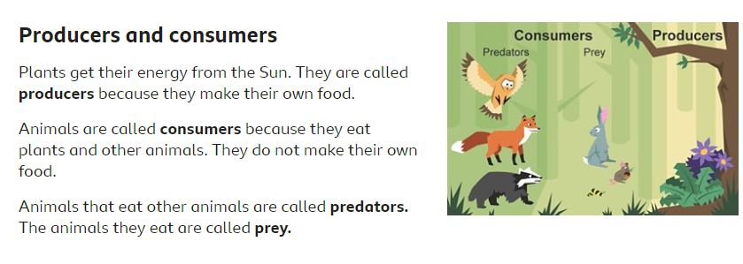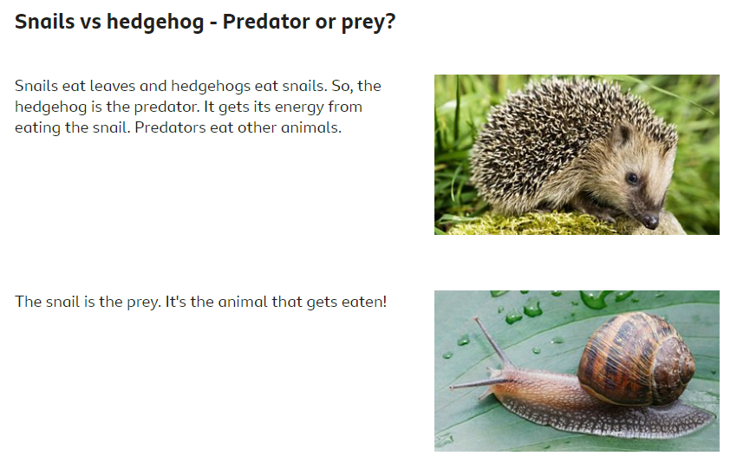
You could create 4 food chains for animals from different habitats.
- Pick a habitat (Polar/Ocean/Woodland/Rainforest)
- Research food chains from that habitat
- Draw and label your food chains- be creative in how you create it!
CHALLENGE- Try to present each habitat differently!
Here are some ideas:
