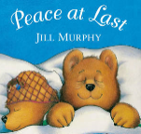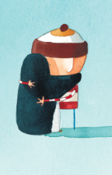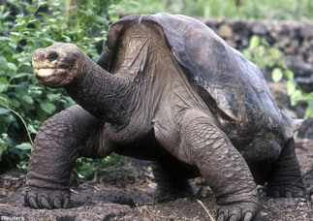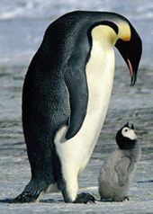

This term we shall continue to build upon our knowledge and understanding of number. We shall continue to practise addition and subtraction and particularly focus on multiplication and division.

We shall be applying this knowledge of number by reasoning, finding the inverse, measuring and finding fractions.

We shall also identify shapes, compare their properties, find fractions of shapes and begin to tell the time to the nearest 5 minutes.

**Maths**

Where possible English lessons will be taught through topic. Our topic this term is ‘**Exciting Explorations**’ where we shall become explorers of the world. In History, we shall be comparing the lives of two significant historical figures: explorers Charles Darwin and Roald Amundsen. We shall learn why they were important, what they did and how they travelled. In Geography, we shall map their journeys, naming continents and seas along the way. In addition, we shall compare the areas of the world they travelled to, learning which areas are hot or cold and relating this to their distance from the equator.

Beginning with Roald Amundsen and Antarctica, we shall innovate a fairy tale to give it settings and characters from this region. We shall also learn more about sentence types, conjunctions, description and suffixes basing some of our grammar on the book ‘The Emperor’s Egg.’ Later in the term, we shall read, explore and write descriptive poetry basing some of our work on the wonderful language of Helen Cowcher’s ‘Antarctica’ and Ruth Heller’s ‘Galapagos means Tortoises.’

As scientists, we shall explore a range of habitats and think about how different animals are adapted to their habitats. We shall explore the food chains of these animals and their interdependence in their habitats. Furthermore, we shall read, explore and write our own non-fiction texts based around these animals.

As artists we shall use photography, clay and music to explore the animals we have studied.

In RE we shall continue to looking at the Christian and Jewish faiths, thinking about New Year, Creation and how the Christian church celebrates Easter.

We will be exploring, reading and writing recounts based on the book ‘Henry’s Map’ and journeys around the village, where we will use our Geographical skills to find out about the local area and draw maps. We will look at the history of schools in the villages, especially boarding schools and read and write letters. We will explore the impact of WW2 on Hanslope and create army trucks. We will learn about Castlethorpe Castle and explore a range of narrative’s set in castles then create our own. We will design historical items; compare and choose appropriate materials and write instructions for our designs. We will also learn about the patron saints and their correspondinmg countries.

We will cover a variety of English skills through these topics, including: Using punctuation correctly, including capital letters, full stops, exclamation marks, question marks, commas and apostrophes; spelling more accurately; beginning to join our handwriting and planning and editing our writing. We will also use a wider range of vocabulary in our writing including noun phrases and suffixes, explore and write different sentence types and use conjunctions to extend our sentences.

**Our Author Studies this term are:**

Oliver Jeffers

Gill Murphy

**Home Study!**

Find out about animals from both Antarctica and Galapagos.

Hunt out microhabitats in your garden or local area. Why do the creatures like it there? What is special about that habitat? Do they share it with any other creatures?

**English/Topic**

**Year 2 Curriculum News**