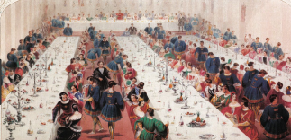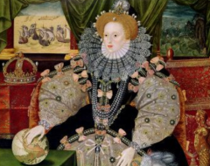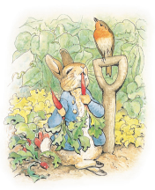

**Diary dates:** 18th June – **Warwick Castle Trip** – Letter to follow soon

20th June – **Sports Day**

3rd July pm - **Banquet** - (Parents/ Carers invited) details will follow very soon.

16th July – **Parent’s Open Evening**

**Our Author Studies this term are:**

Beatrix Potter

Mo Willems

**Home Study!**

Grow some plants at home to find out how they grow best.

Look out for any news on the royal family and who it involves.

**Maths**

This term we will continue to practise our methods for addition, subtraction, multiplication and division. We will apply these in a variety of contexts.

We will be beginning to tell the time to the nearest 5 minutes; measuring in different ways especially using a variety of scales and finding fractions of amounts.

We will identify shapes, compare their properties and read and create graphs.

This term our topic is **‘A Right Royal Banquet’** where we will learn about different Kings and Queens, time periods and food. In History, we will be comparing the lives of different monarchs. We will also explore royal banquets and plan our own.

In Geography, we will learn about the countries and cities of the UK.

We will read and write royal themed stories and create our own ‘breaking news’ reports about the royal family. We will also create invites and menus for our own royal banquet. Dates to follow soon.

As scientists we will grow our own salad plants and find out about what plants and bulbs need in order to grow. We will explore a range of food, learning what our bodies need to stay healthy and what makes a healthy diet. We will also look at the role of exercise in a healthy diet.

As artists we will create self-portraits and look at the Armada Portrait as inspiration. Our DT will mostly focus on food this term: creating menus, recipes and food for our banquet. We will also look at royal fashion and create outfits fit for a King or Queen.

In RE we will continue to looking at the Christian and Jewish faiths, thinking about whether stories can change people and how people of different faiths spend their weekend.

**English/Topic**

**Year 2 Curriculum News**