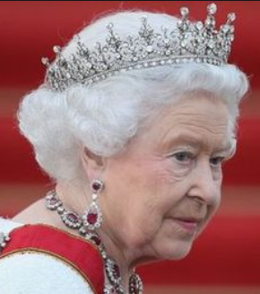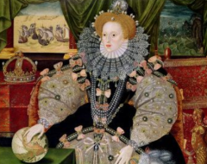

**Maths**

This term we will continue to practise our methods for addition, subtraction, multiplication and division. We will consolidate addition as a new method and apply these skills in a variety of contexts.

We will be learning about fractions of shapes and amounts and relating this to our work on Division.

We will revise shapes and reading scales.

We will use positional language and relate this to our work on fractions making half, quarter and three quarter turns.

This half term our topic is **‘Real Royals’** where we will learn about different Kings and Queens, time periods and the current Royal family. In History, we will be comparing the lives of different monarchs. We will also explore how the UK has changed in different time periods.

We will read and write royal themed stories based on David Walliams the Queen’s Orangutang and use The Witch’s Children to create our own ‘breaking news’ reports about the royal family. We will continue to concentrate on punctuating our sentences accurately and focus more on exclamation marks, question marks, commas and apostrophes. We will also learn to use a variety of conjunctions in our writing

As scientists we will concentrate this term on developing our working scientifically skills; thinking about asking and answering scientific questions and collecting data.

As artists we will create self-portraits and look at the Armada Portrait as inspiration. We will also look at royal fashion and create outfits fit for a King or Queen.

In RE we will continue to look at the Christian and Jewish faiths, thinking about whether stories can change people.

**Our Author Study this term is:**

Emily Gravett

**Home Study!**

Look out for any news on the royal family and who it involves.

Find out about a King or Queen you are interested in.

**English/Topic**

**Year 2 Curriculum News**